**Chapter 9. Security, privacy and data integrity**

security is protecting data from loss/corruption

integrity is ensuring the consistency

privacy: protect data from unauthorised access

Threats to the security of a computer system and of the data stored in it

* individual user not taking appropriate care
* internal mismanagement
* natural disasters
* unauthorised instrusion into the system by an individual
* malicious software entering the system

MALWARE

* virus:tries to replicate itself inside other executable code
* worm:runs independently and transfers itself to other network hosts
* logic bomb:stays inactive until some condition is met
* Trojan horse:replaces all or part of a previously useful program
* spyware:collects infrormation and transmits it to another system
* bot:take control of another computer and uses it to launch attacks

ACTIVITY BEHAVIOUR

* phishing:sending an email or electronic message from an apparently legitimate source requesting confidential information
* pharming:setting up a bogus website which appears to be a legitimate site
* keylogger:recording keyboard usage by the legitimate user of the system

PROTECTING COMPUTER SYSTEMS

Disaster recovery

* full backup
* incremental backup
* disk mirrorring

If an organisation has a full system always ready to replace the normally operational one, it is referred to as a 'hot site'.Remote from the original system.

Safe system update

Authentication: vertification of a user's identity

* account password
* face configuration
* iris configuration
* fingerprint scanning
* IC card

Authorisation: definition of user's access rights to system components

表单验证 (Form)Validation - REASONABLE:

-DEFINITION-

* needed to check that the data entered is reasonable

-EXAMPLES-

* a presence check #栏空着
* a format check #生日格式 dd/mm/yyyy
* a length check #电话号码
* a range check #月份填写不能超出 1-12 个月
* a limit check #年龄填写限制 e.g. 0-130
* a type check #填写收入，必须填阿拉伯数字
* an existence check #查看名字是否与历史重复

正确验证 Verification - DATA CORRECTNESS :

-DEFINITION-

* needed to ensure that the data entered exactly matches the original source is consistent

-EXAMPLES-

* double entry
* visual check

-DATA TRANSFER-

parity check 奇偶校验 :

even parity - even number of errors, error can't be detected

+DEFINITION+

* At the transmitting end, the number of 1s in the seven-bit code is counted
* If the count gives an even number, the parity bit is set to 0
* If the count gives an odd number, the parity bit is set to 1
* This is repeated for every byte in the transmission
* At the receiving end, the number of 1s in the eight-bit code is counted
* If the count gives an even number, the byte is accepted
* This is repeated for every byte in the transmission
* If no errors are found, the transmission is accepted
* If an error is detected, re-transmission has to be requested

Parity block - 双向奇偶校验

Intersection point - error position

-Checksums-

When a block of data is about to be transmitted, the checksum for the bytes is first calculated.This value is transmitted with the block of data.At the receiving end, the checksum is re-calculated from the block of data received.This calculated value is compared to the checksum transmitted.If they are the same, then the data was transmitted without any errors; if they are different, then a request is sent for the data to be re-calculated.

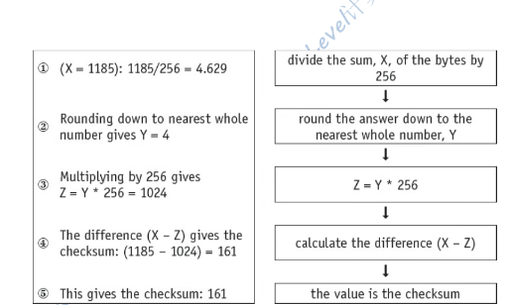

-Check digit-

barcode(ISBN) scanner whether is correct